2

Server Virtualization Systems

Introduction
Since many years, server virtualisation is a standard in corporate environment. Whereas in the old days, each and every service needed its own dedicated hardware, virtualisation enabled admins to share the resources of a single hardware server among several isolated virtual machines to enhance overall energy and cost efficiency. One virtualisation server can replace tens of physical servers which offers many advantages:
- Less hardware to manage
- Less capital expenses for hardware acquirement
- Lower energy consumption
- Less space consumption
- High flexibility
- hardware maintenance becomes a software problem

During this project you’ll have to acquire new knowledge about topics related to the concept of virtualisation. You will have to become an expert of these topics and explain the topics to your classmates and your teachers in a documentation, video tutorial and presentation.

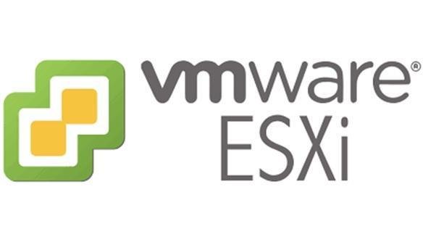


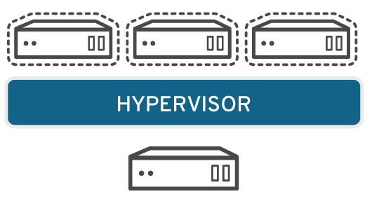

Groups and Topics
General
In teams of two students (same groups as CLOIF2), you must use various virtualisation software solutions and compare them to each other. The following features have to be addressed during the project:

- Deployment of the 2 different virtualisation environments (so-called type 1 hypervisors) Max
- Creation and configuration of virtual machines using the GUI Max
- Creation and configuration of virtual machines using the CLI Max
- Installation of a single Windows client and a single Linux server OS within virtual machines Max
- Change the configuration of virtual machines (add/remove resources as CPU, RAM, HDD, NICs, …)Max
- Duplicate (Clone) a virtual machine Max
- Export a virtual machine Max
- Backup the hypervisor configuration Max
- Backup a virtual machine (Built-in, script or using a 3rd party software)Max
- Use snapshots of virtual machines Max
- Create virtual machine templates Max
- Use remote storage to save VM files (CLOIF2 NAS) Max
- Live migration of an existing (running and stopped) virtual machine from one storage to another Max
- Live migration of an existing (running and stopped) virtual machine from one hypervisor to another Max
- Manage users and permissions in the hypervisor
- Patch the hypervisor with the latest updates

Each feature must be implemented using a practical example using your servers. CLOIF2 storage servers should be used as network storage. The topic “Live migration of an existing virtual machine from one storage to another” must be configured using different protocols, for example SMB, NFS, iSCSI but this depends strongly on the hypervisor and the NAS software and their compatibility.
As each team has 2 different storage locations (local on the hypervisor, remote on the CLOIF2 server), you must configure your storage server to provide two different storage protocols. You are free to choose which storage protocol you use for the virtualisation solution you are configuring.

Specialisation
While implementing the above steps with both hypervisors, each group must also specialise in one of the following topics:

Team | Topic
1 | User Management & Permissions
2 | Storage Migration & Hypervisor Migration
3 | Hypervisor CLI & Automation
4 | Virtual machine Backup & Hypervisor Backup
5 | Snapshots & Templates
6 | High Availability
7 | Clustering

“Specialise” in this context means that:
- you should understand and be able to explain the concept
- you should be able to implement it in both hypervisors
- you should be able to name some “do’s and don’ts” related to your topic

Hypervisors
During this project, you must familiarise with the following 2 hypervisors:
- VMWare ESXi
VMWare is the industry leading solution for virtualisation in corporate environment and has a large choice of virtualisation products for personal or professional use.
- Proxmox VE
Proxmox is an opensource virtualisation solution supported by growing and large community.
Both solutions are similar in their feature set, but whereas the VMWare solution is a commercial product, the Proxmox solution offers very similar functionality for free.

Deliverables
For the evaluation of this project, each group must deliver 4 parts:
- Correctly installed and configured virtualisation solutions
- Documentation of the implementation of all the features mentioned above including pictures and technical details. This report should be properly formatted and include:
  - Title page
  - TOC, TOF
  - A chapter for each virtualisation feature where you explain the implementation in both hypervisors and compare both solutions. You should also write about experiences problems and impediments.
  - A personal conclusion at the end which summarizes the whole project.
- At least 1 video tutorial on relevant topics. The video tutorials must include a demonstration of a practical setup of the topic. The video should not only be a series of screenshots but should contain audio comments related to the configuration you are setting up. To record your screen, you can use a screencast software like CamStudio.
- Presentation of your specialisation topic. During this presentation, you must explain the theoretical concept of your topic and show how it has been implemented on both hypervisors. The presentation includes a live demonstration. The live demo only needs to be done on one of both hypervisors to avoid the necessity of rebooting the servers. Each presentation takes 20 minutes including live demo and Q&A.

Evaluation
The evaluation of this project will count for 100% of the final grade of the total VIRCL module and take into consideration the individual quality of the deliverables:
- Project management reports and meetings (10P)
- Installation report (20P)
- Video tutorial (10P)
- Presentation of your specialisation topic (20P)

The total 60P will be divided by 3 which then equals to the final course grade on 20P.

Grade Switching

We are aware, that sometimes in life, teams don’t work in perfect harmony and sometimes it may happen, that one person does most of the job while the partner “takes it easy”. To compensate for such a behaviour and to promote fairness, we introduce the concept of grade switching, where we make it possible to switch a maximum of 5 points from one team member to his partner. The conditions are as follows:
- The team has to discuss this internally and both members need to accept
- The team needs to decide how many points should be switched
- The team has to contact the teachers before the end of the project
- The team needs to provide some proof of the unfair workload distribution

Example:
The team XY with members Alice and Bob decides mutually that Alice did substantially more work than Bob. They choose a grade switching of 2 points. At the end of the semester, their grade as a team is 45/60. This means that:
- Alice gets 45 + 2 = 47/60 -> 15,6/20 final grade
- Bob gets 45 - 2 = 43/60 -> 14,3/20 final grade

Project Planning and Deadlines
The following table indicated the mandatory tasks and deadlines. In order to guide and help you during the progress of the project, 3 so-called “retrospective meetings” will be held between you and both teachers. The goals of these meetings are:
- to reflect on what has been done,
- to assess your current project position and discuss problems and impediments and
- to plan the actions of the next weeks until the next meeting.
These meetings must be well prepared as you need to show the teachers your work done and explain the next steps. Before and after each meeting, you need to create a meeting report which summarizes the decisions taken and the future steps. A template can be found on eduMoodle.

Week | Content
1 – 13.04-17.04 | - Start of the project  - Introduction and explanations  - Server room tour  - Team organisation (Creation of a new team in MS Teams for coordination)  - Research on PM tool for time and task management
2 – 20.04-25.04 | - Autonomous work  - Group meeting
3 – 27.04-01.05 | - Autonomous work  - Group meeting  - Retrospective meeting 1
4 – 04.05-08.05 | - Autonomous work  - Group meeting
5 – 11.05-15.05 | - Autonomous work  - Group meeting
6 – 18.05-22.05 | - Autonomous work  - Group meeting  - Retrospective meeting 2
Holiday
7 – 01.06-05.06 | - Autonomous work  - Group meeting
8 – 08.06-12.06 | - Autonomous work  - Upload of the deliverables
9 – 15.06-19.06 | - Presentations
10 – 22.06 | - Debriefing  - CLOIF2 server disassembly
Notes:
- Retrospective meetings will take place in presence.
- The practical part ends on June 10th, 2026. On this day, every team must upload the deliverables to eduMoodle.

Tips on the Hypervisor Installation
- The VMWare ESXi and Proxmox ISO file, required for the installation, must be remotely mounted using the Integrated Lights-Out (iLO) interface of the HP server.
- Use the same IP-Addresses for your NIC in the ESXi and the Proxmox server as stated on the last page in this document.
- The use of vCenter is mandatory for most of the functionality.

Server Details
The following screenshot shows all the necessary information of the servers provided to you for this project. These virtualisation servers are put at your disposal and you can use them when and how you want, as long as it’s for educational purposes. You can also connect to the servers from home using a VPN connection. For more details on VPN, ask M. Ludwig.

Location | Server Name | Server LAN1 IP | Server LAN1 hostname | ILO/RMM IP | VM IP Range | Hyper-visor | Name
Server room | HP01 | 10.0.10.11 | HP01 | 192.168.0.1 | 10.0.10.13-10.0.10.19
Server room | HP02 | 10.0.10.21 | HP02 | 192.168.0.2 | 10.0.10.23-10.0.10.29
Server room | HP03 | 10.0.10.31 | HP03 | 192.168.0.3 | 10.0.10.33-10.0.10.39
Server room | HP04 | 10.0.10.41 | HP04 | 192.168.0.4 | 10.0.10.43-10.0.10.49
Server room | HP05 | 10.0.10.51 | HP05 | 192.168.0.5 | 10.0.10.53-10.0.10.59
Server room | HP06 | 10.0.10.61 | HP06 | 192.168.0.6 | 10.0.10.63-10.0.10.69
Server room | HP07 | 10.0.10.71 | HP07 | 192.168.0.7 | 10.0.10.73-10.0.10.79
Server room | HP08 | 10.0.10.81 | HP08 | 192.168.0.8 | 10.0.10.83-10.0.10.89
Server room | HP09 | 10.0.10.91 | HP09 | 192.168.0.9 | 10.0.10.93-10.0.10.99 | pmve | Sven
Server room | HP10 | 10.0.10.101 | HP10 | 192.168.0.10 | 10.0.10.103-10.0.10.109 | pmve | Eric
Server room | HP11 | 10.0.10.111 | HP11 | 192.168.0.11 | 10.0.10.113-10.0.10.119 | esxi | Max
Server room | HP12 | 10.0.10.121 | HP12 | 192.168.0.12 | 10.0.10.123-10.0.10.129 | esxi
Server room | HP13 | 10.0.10.131 | HP13 | 192.168.0.13 | 10.0.10.133-10.0.10.139
Server room | HP14 | 10.0.10.141 | HP14 | 192.168.0.14 | 10.0.10.143-10.0.10.149
Server room | HP15 | 10.0.10.151 | HP15 | 192.168.0.15 | 10.0.10.153-10.0.10.159
Server room | HP16 | 10.0.10.161 | HP16 | 192.168.0.16 | 10.0.10.163-10.0.10.169

Important:
- Make sure to respect network address conventions as otherwise you may sabotage the whole network.
- You don’t need to change any network settings in BIOS/UEFI!
- Please always think about powering off the servers if you don’t need them!
- Use the central server management interface (10.0.10.1) to quickly start/stop your server. In case, ILO/RMM is not reacting properly, you can reset it there.
- To access iLO/RMM on your server use the username root and password test..123. Change that password as soon as you logged in.
- DO NOT DELETE OR MODIFY THE USER RemoteManAdmin !!!!!

